Data communication and computer networks Lab

Semester:6th



Lab Report # 8

Submitted By: Zainab Khalid
Registration No:19PWCSE1743
Section: A
Submitted to: Engr Faiz Ullah

Department of Computer Systems Engineering
University of Engineering and Technology Peshawar
CSE 303L: Data Communication and Computer Networks
Credit Hours: 1

Demonstration of Concepts | Poor (Does not meet expectation (1))  The student failed to demonstrate a clear understanding of the assignment concepts | Fair (Meet Expectation (2-3))  The student demonstrated a clear understanding of some of the assignment concepts | Good (Exceeds Expectation (4-5)  The student demonstrated a clear understanding of the assignment concepts | Score  30%
Accuracy | The student mis-configured enough network settings that the lab computer couldn't function properly on the network | The student configured enough network settings that the lab computer partially functioned on the network | The student configured the network settings that the lab computer fully functioned on the network | 30%
Following Directions | The student clearly failed to follow the verbal and written instructions to successfully complete the lab | The student failed to follow the some of the verbal and written instructions to successfully complete all requirements of the lab | The student followed the verbal and written instructions to successfully complete requirements of the lab | 20%
Time Utilization | The student failed to complete even part of the lab in the allotted amount of time | The student failed to complete the entire lab in the allotted amount of time | The student completed the lab in its entirety in the allotted amount of time | 20%

Lab 8

Introduction to Cisco Packet Tracer

OBJECTIVES OF THE LAB
--------------------------------------------------------------------------------------------------------------
This lab aims to introduce Cisco Packet Tracer. Some specific topics covered in this lab are
- Creating Networks
- Making Connections
- Making LAN using Hub
- Making LAN using Switch
- Difference between hub and switch
-------------------------------------------------------------------------------------------------------------

Introduction
Cisco Packet Tracer is an innovative network simulation and visualization tool. This free software helps you to practice your network configuration and troubleshooting skills via your desktop computer or an Android or iOS based mobile device. Packet Tracer is available for both the Linux and Windows desktop environments.

With Packet Tracer you can choose to build a network from scratch, use a pre-built sample network, or complete classroom lab assignments. Packet Tracer allows you to easily explore how data traverses your network. Packet Tracer provides an easy way to design and build networks of varying sizes without expensive lab equipment.

- Creating Devices
  - Choose a device type from the Device-Type Selection box
  - Click on the desired device model from the Device-Specific Selection box
  - Click on a location in the workspace to put your device in that location
  - If you want to cancel your selection, press the Cancel icon for that device
  - Alternatively, you can click and drag a device from the Device-Specific Selection box onto the workspace
  - You can also click and drag a device directly from the Device-Type Selection box and a default device model will be chosen for you

- Making Connections
  - To make a connection between two devices, first click the Connections icon from the Device-Type Selection box to bring up the list of available connections.
  - Then click the appropriate cable type.
  - The mouse pointer will change into a "connection" cursor.
  - Click on the first device and choose an appropriate interface to which to connect.
  - Then click on the second device and do the same.
  - A connection cable will appear between the two devices, along with link lights showing the link status on each end (for interfaces that have link lights).

- Creating Networks
Packet Tracer is a cross-platform visual simulation tool designed by Cisco Systems that allows users to create network topologies and imitate modern computer networks. The software allows users to simulate the configuration of Cisco routers and switches using a simulated command line interface.

- Make a LAN using HUB in Cisco Packet Tracer.

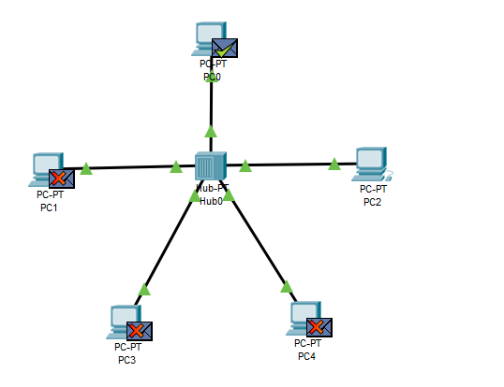
- Make LAN using SWITCH in Cisco Packet Tracer.
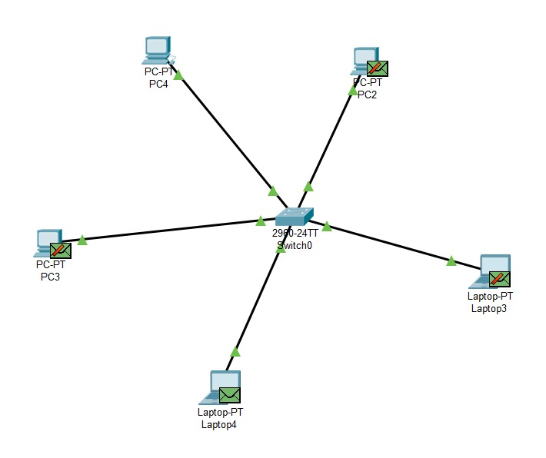

- What are the pros and cons of HUB?

HUBS:
Hub is the central point of a networking device that connects multiple hosting devices to one network. It allows data to urge transferred between themselves by functioning as a multi-port repeater. For this purpose, it uses either a fiber optic cable or a twisted pair cable.

FEATURES:
The following are features of the network hub device:

- Operates in half-duplex mode.
- Available in 4 to 24 port sizes.
- Hosts are liable for collision detection.
- There are three types of viz. active hub, passive hub, and intelligent hub.

PROS/ADVANTAGES OF HUB:
- Easy to install
- Very little delay
- It is used for internal connectivity between the system
- Can different media type
- Cheaper
- Hub device does not affect the performance of the network seriously
- It can extend the total distance of the network

CONS/DISADVANTAGES OF HUB:
- It runs half-duplex
- Cannot filter information
- It cannot connect different types of network architecture such as a token ring and Ethernet extra
- It does not have a mechanism to reduce the network traffic
- Passes packet to all connected segment
- Cannot reduce network traffic
- It will broadcast to all the port
- Extend the collision

- What are the pros and cons of SWITCH?

SWITCH:
It is a networking device that transfers data only to the host where it is being addressed. It checks the destination address to route the packet appropriately.

FEATURES:
the following are features of the network switches:
- It operates at layer-2 (data link layer).
- It is available in various configurations and as per data transfer speeds such as 10/100/1000 Mbps or 10/100 Gbps.
- Operates in full duplex mode
- Packet collision is avoided due to port to port data transmission.

PROS/ ADVANTAGES OF SWITCHES:
Following are the benefits or advantages of Switches:
- They increase the available bandwidth of the network.
- They help in reducing workload on individual host PCs.
- They increase the performance of the network.
- Networks that use switches will have less frame collisions. This is due to the fact that switches create collision domains for each connection.
- Switches can be connected directly to workstations.

CONS/DISADVANTAGES OF SWITCHES:
Following are the disadvantages of Switches:
- They are more expensive compare to network bridges.
- Network connectivity issues are difficult to be traced through the network switch.
- Broadcast traffic may be troublesome.
- If switches are in promiscuous mode, they are vulnerable to security attacks e.g. spoofing IP address or capturing of ethernet frames.
- Proper design and configuration is needed in order to handle multicast packets.
- While limiting broadcasts, they are not as good as routers.

- Which ethernet cable did you use for the connection between HUB and PC?
The ethernet cable used for the connection between HUB and PC is STRAIGHT THROUGH.

- What does a switch store in its memory?
The switch will store this information in a MAC address table that it keeps in memory. When the switch has seen at least one frame from each connected device it will know exactly which MAC addresses that are connected to what ports, and it will then also be able to forward traffic only to the correct destination ports.

